**INDIA GENERAL ELECTIONS RESULT ANALYSIS 2024**

DROP TABLE IF EXISTS constituencywise_details;

CREATE TABLE constituencywise_details

(

S_N INT,

Candidate VARCHAR(100),

Party VARCHAR(100),

EVM_Votes INT,

Postal_Votes INT,

Total_Votes INT,

of_Votes FLOAT,

Constituency_ID VARCHAR(50)

);

SELECT * FROM constituencywise_details

DROP TABLE IF EXISTS constituencywise_results;

CREATE TABLE constituencywise_results

(

S_No INT,

Parliament_Constituency VARCHAR(100) Primary Key,

Constituency_Name VARCHAR(100),

Winning_Candidate VARCHAR(150),

Total_Votes INT,

Margin INT,

Constituency_ID VARCHAR(50),

Party_ID INT

);

SELECT * FROM constituencywise_results

DROP TABLE IF EXISTS partywise_results;

CREATE TABLE partywise_results

(

Party VARCHAR(150),

Won INT,

Party_ID INT Primary Key

);

SELECT * FROM partywise_results

CREATE TABLE statewise_results

(

Constituency VARCHAR(100),

Const_No INT,

Parliament_Constituency VARCHAR(100) Primary Key,

Leading_Candidate VARCHAR(150),

Trailing_Candidate VARCHAR(100) NULL,

Margin INT,

Status VARCHAR(100),

State_ID VARCHAR(100),

State VARCHAR(100)

);

SELECT * FROM statewise_results

CREATE TABLE states

(

STATE_ID VARCHAR(50) Primary Key,

State VARCHAR(50)

)

SELECT * FROM states

--PROBLEM STATEMENT

--1. TOTAL SEATS

SELECT

DISTINCT COUNT(Parliament_Constituency) as Total_Seats

FROM constituencywise_results



--2. WHAT ARE THE TOTAL NUMBER OF SEATS AVAILABLE FOR ELECTION IN EACH STATE

SELECT

s.state AS State_name,

COUNT(cr.parliament_constituency) AS Total_Seats

FROM

constituencywise_results cr

INNER JOIN statewise_results sr ON cr.Parliament_Constituency = sr.Parliament_Constituency

INNER JOIN states s ON sr.State_ID = s.State_ID

GROUP BY s.state

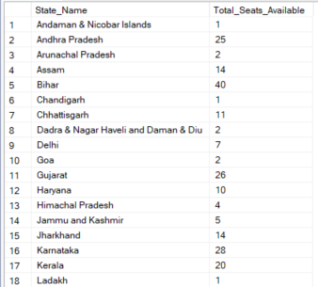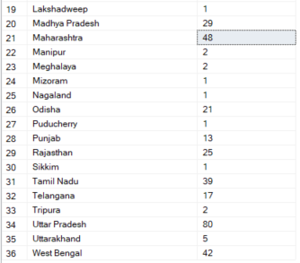

--3. TOTAL SEATS WON BY NDA ALLIANCE

SELECT

SUM(CASE

WHEN party IN (

'Bharatiya Janata Party - BJP',

'Telugu Desam - TDP',

'Janata Dal (United) - JD(U)',

'Shiv Sena - SHS',

'AJSU Party - AJSUP',

'Apna Dal (Soneylal) - ADAL',

'Asom Gana Parishad - AGP',

'Hindustani Awam Morcha (Secular) - HAMS',

'Janasena Party - JnP',

'Janata Dal (Secular) - JD(S)',

'Lok Janshakti Party(Ram Vilas) - LJPRV',

'Nationalist Congress Party - NCP',

'Rashtriya Lok Dal - RLD',

'Sikkim Krantikari Morcha - SKM'

) THEN Won

ELSE 0

END) AS NDA_Total_Seats_Won

FROM

partywise_results

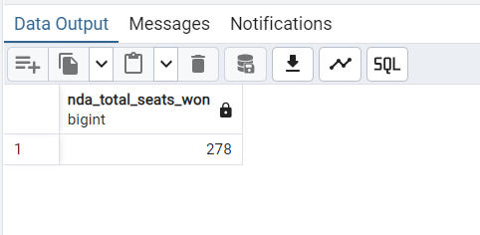

--4. SEATS WON BY NDA ALLIANCE PARTIES

SELECT

party as Party_Name,

won as Seats_Won

FROM

partywise_results

WHERE

party IN (

'Bharatiya Janata Party - BJP',

'Telugu Desam - TDP',

'Janata Dal (United) - JD(U)',

'Shiv Sena - SHS',

'AJSU Party - AJSUP',

'Apna Dal (Soneylal) - ADAL',

'Asom Gana Parishad - AGP',

'Hindustani Awam Morcha (Secular) - HAMS',

'Janasena Party - JnP',

'Janata Dal (Secular) - JD(S)',

'Lok Janshakti Party(Ram Vilas) - LJPRV',

'Nationalist Congress Party - NCP',

'Rashtriya Lok Dal - RLD',

'Sikkim Krantikari Morcha - SKM'

)

ORDER BY Seats_Won DESC

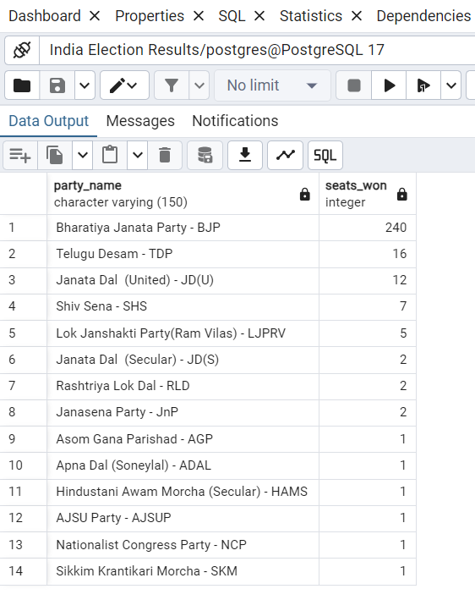

--5. TOTAL SEATS WON BY I.N.D.I.A. ALLIANCE

SELECT

SUM(CASE

WHEN party IN (

'Indian National Congress - INC',

'Aam Aadmi Party - AAAP',

'All India Trinamool Congress - AITC',

'Bharat Adivasi Party - BHRTADVSIP',

'Communist Party of India (Marxist) - CPI(M)',

'Communist Party of India (Marxist-Leninist) (Liberation) - CPI(ML)(L)',

'Communist Party of India - CPI',

'Dravida Munnetra Kazhagam - DMK',

'Indian Union Muslim League - IUML',

'Nat`Jammu & Kashmir National Conference - JKN',

'Jharkhand Mukti Morcha - JMM',

'Jammu & Kashmir National Conference - JKN',

'Kerala Congress - KEC',

'Marumalarchi Dravida Munnetra Kazhagam - MDMK',

'Nationalist Congress Party Sharadchandra Pawar - NCPSP',

'Rashtriya Janata Dal - RJD',

'Rashtriya Loktantrik Party - RLTP',

'Revolutionary Socialist Party - RSP',

'Samajwadi Party - SP',

'Shiv Sena (Uddhav Balasaheb Thackrey) - SHSUBT',

'Viduthalai Chiruthaigal Katchi - VCK'

) THEN Won

ELSE 0

END) AS INDIA_Total_Seats_Won

FROM

partywise_results

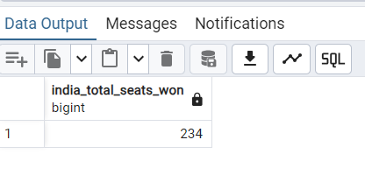

--6. SEATS WON BY I.N.D.I.A. ALLIANCE PARTIES

SELECT

party as Party_Name,

won as Seats_Won

FROM

partywise_results

WHERE

party IN (

'Indian National Congress - INC',

'Aam Aadmi Party - AAAP',

'All India Trinamool Congress - AITC',

'Bharat Adivasi Party - BHRTADVSIP',

'Communist Party of India (Marxist) - CPI(M)',

'Communist Party of India (Marxist-Leninist) (Liberation) - CPI(ML)(L)',

'Communist Party of India - CPI',

'Dravida Munnetra Kazhagam - DMK',

'Indian Union Muslim League - IUML',

'Nat`Jammu & Kashmir National Conference - JKN',

'Jharkhand Mukti Morcha - JMM',

'Jammu & Kashmir National Conference - JKN',

'Kerala Congress - KEC',

'Marumalarchi Dravida Munnetra Kazhagam - MDMK',

'Nationalist Congress Party Sharadchandra Pawar - NCPSP',

'Rashtriya Janata Dal - RJD',

'Rashtriya Loktantrik Party - RLTP',

'Revolutionary Socialist Party - RSP',

'Samajwadi Party - SP',

'Shiv Sena (Uddhav Balasaheb Thackrey) - SHSUBT',

'Viduthalai Chiruthaigal Katchi - VCK'

)

ORDER BY Seats_Won DESC

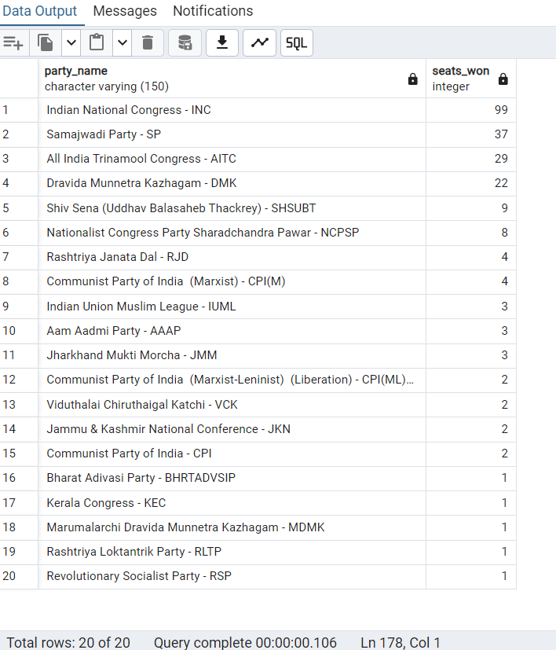

--7. ADD NEW COLUMN FIELD IN TABLE PARTYWISE_RESULT TO GET THE PARTY ALLIANCE AS NDA, I.N.D.I.A. AND OTHERS

ALTER TABLE partywise_results

ADD party_alliance VARCHAR(50);

--I.N.D.I.A Allianz

UPDATE partywise_results

SET party_alliance = 'I.N.D.I.A'

WHERE party IN (

'Indian National Congress - INC',

'Aam Aadmi Party - AAAP',

'All India Trinamool Congress - AITC',

'Bharat Adivasi Party - BHRTADVSIP',

'Communist Party of India (Marxist) - CPI(M)',

'Communist Party of India (Marxist-Leninist) (Liberation) - CPI(ML)(L)',

'Communist Party of India - CPI',

'Dravida Munnetra Kazhagam - DMK',

'Indian Union Muslim League - IUML',

'Jammu & Kashmir National Conference - JKN',

'Jharkhand Mukti Morcha - JMM',

'Kerala Congress - KEC',

'Marumalarchi Dravida Munnetra Kazhagam - MDMK',

'Nationalist Congress Party Sharadchandra Pawar - NCPSP',

'Rashtriya Janata Dal - RJD',

'Rashtriya Loktantrik Party - RLTP',

'Revolutionary Socialist Party - RSP',

'Samajwadi Party - SP',

'Shiv Sena (Uddhav Balasaheb Thackrey) - SHSUBT',

'Viduthalai Chiruthaigal Katchi - VCK'

);

--NDA Allianz

UPDATE partywise_results

SET party_alliance = 'NDA'

WHERE party IN (

'Bharatiya Janata Party - BJP',

'Telugu Desam - TDP',

'Janata Dal (United) - JD(U)',

'Shiv Sena - SHS',

'AJSU Party - AJSUP',

'Apna Dal (Soneylal) - ADAL',

'Asom Gana Parishad - AGP',

'Hindustani Awam Morcha (Secular) - HAMS',

'Janasena Party - JnP',

'Janata Dal (Secular) - JD(S)',

'Lok Janshakti Party(Ram Vilas) - LJPRV',

'Nationalist Congress Party - NCP',

'Rashtriya Lok Dal - RLD',

'Sikkim Krantikari Morcha - SKM'

);

--OTHER

UPDATE partywise_results

SET party_alliance = 'OTHER'

WHERE party_alliance IS NULL;

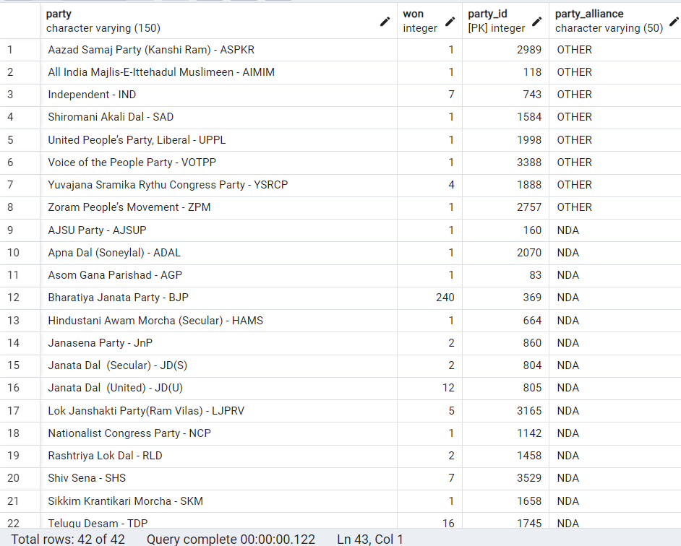

--8. WHICH PARTY ALLIANCE(NDA, I.N.D.I.A., OR OTHER) WON THE MOST SEATS ACROSS ALL STATES?

SELECT

party_alliance,

SUM(won)

FROM partywise_results

GROUP BY party_alliance

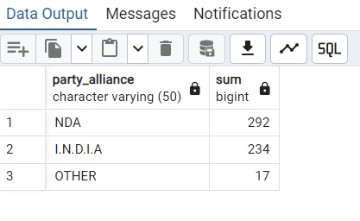

-- 9. WINNING CANDIDATE'S NAME, THIER PARTY NAME, TOTAL VOTES, AND THE MARGIN OF VICTORY FOR A SPECIFIC STATE AND

-- CONSTITUENCY?

SELECT

cr.Winning_Candidate,

pr.party,

pr.party_alliance,

cr.total_votes,

cr.margin,

s.state,

cr.Constituency_Name

FROM

constituencywise_results cr INNER JOIN partywise_results pr ON cr.party_id = pr.party_id

INNER JOIN statewise_results sr ON cr.Parliament_Constituency = sr.Parliament_Constituency

INNER JOIN states s ON sr.state_id = s.state_id

WHERE cr.Constituency_Name = 'BARAMATI'

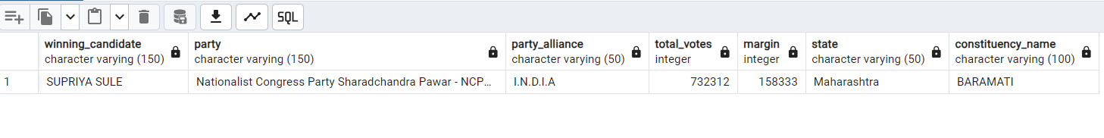

-- 10. WHAT IS THE DISTRIBUTION OF EVM VOTES VERSUS POSTAL VOTES FOR CANDIDATES IN A SPECIFIC CONSTITUENCY?

SELECT

cd.EVM_Votes,

cd.Postal_Votes,

cd.Total_Votes,

cd.Candidate,

cr.Constituency_Name

FROM constituencywise_results cr JOIN constituencywise_details cd

ON cr.Constituency_ID = cd.Constituency_ID

WHERE cr.Constituency_Name = 'ALLAHABAD'

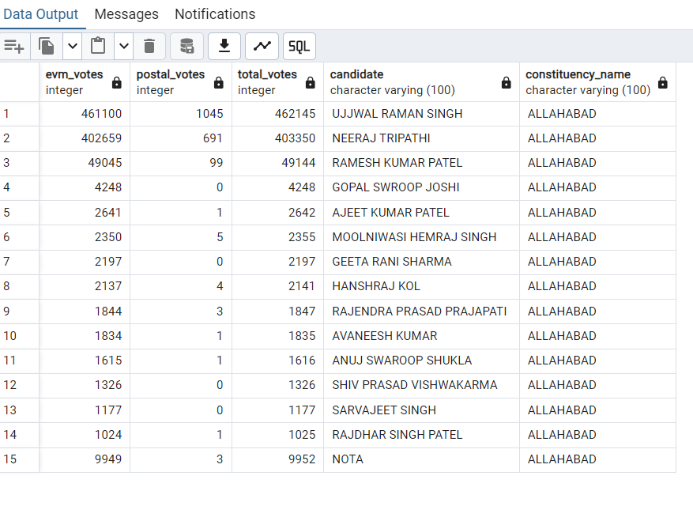

-- 11. WHICH PARTIES WON THE MOST SEATS IN S STATE, AND HOW MANY SEATS DID EACH PARTY WIN?

SELECT

s.state,

pr.Party_alliance

FROM

constituencywise_results cr

JOIN

partywise_results pr ON cr.Party_ID = pr.Party_ID

JOIN

statewise_results sr ON cr.Parliament_Constituency = sr.Parliament_Constituency

JOIN states s ON sr.State_ID = s.State_ID

WHERE

s.state = 'Uttar Pradesh'

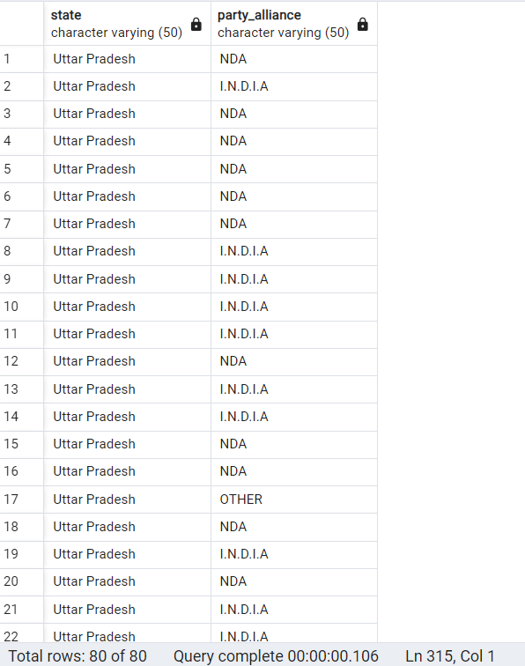

-- 12. WHAT IS THE TOTAL NUMBER OF SEATS WON BY EACH PARTY ALLIANCE (NDA, I.N.D.I.A, AND OTHER) IN EACH STATE FOR THE INDIA ELECTIONS 2024 ?

SELECT

s.State AS State_Name,

SUM(CASE WHEN p.party_alliance = 'NDA' THEN 1 ELSE 0 END) AS NDA_Seats_Won,

SUM(CASE WHEN p.party_alliance = 'I.N.D.I.A' THEN 1 ELSE 0 END) AS INDIA_Seats_Won,

SUM(CASE WHEN p.party_alliance = 'OTHER' THEN 1 ELSE 0 END) AS OTHER_Seats_Won

FROM

constituencywise_results cr

JOIN

partywise_results p ON cr.Party_ID = p.Party_ID

JOIN

statewise_results sr ON cr.Parliament_Constituency = sr.Parliament_Constituency

JOIN

states s ON sr.State_ID = s.State_ID

WHERE

p.party_alliance IN ('NDA', 'I.N.D.I.A', 'OTHER') -- Filter for NDA and INDIA alliances

GROUP BY

s.State

ORDER BY

s.State;

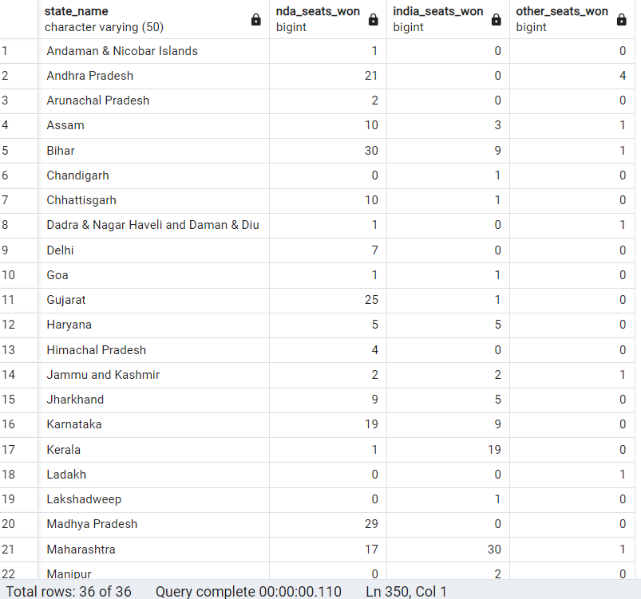

-- 13. WHICH CANDIDATE RECEIVED THE HIGHEST NUMBER OF EVM VOTES IN EACH CONSTITUENCY (TOP 10)?

SELECT

cr.Constituency_Name,

cd.Constituency_ID,

cd.Candidate,

cd.EVM_Votes

FROM

constituencywise_details cd

JOIN

constituencywise_results cr ON cd.Constituency_ID = cr.Constituency_ID

WHERE

cd.EVM_Votes = (

SELECT MAX(cd1.EVM_Votes)

FROM constituencywise_details cd1

WHERE cd1.Constituency_ID = cd.Constituency_ID

)

ORDER BY

cd.EVM_Votes DESC

LIMIT 10;

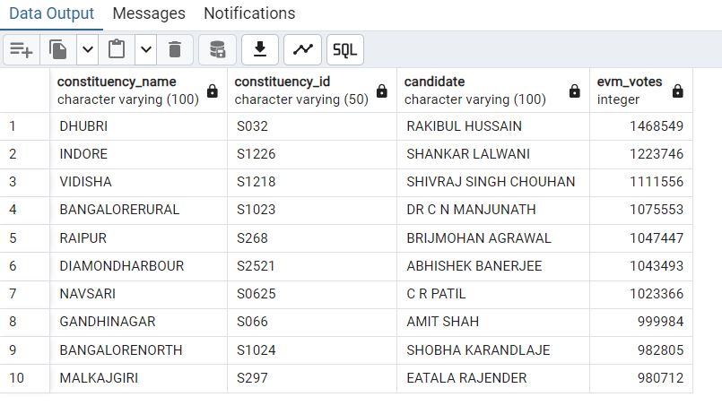

-- 14. WHICH CANDIDATE WON AND WHICH CANDIDATE WAS THE RUNNER-UP IN EACH CONSTITUENCY OF STATE FOR THE 2024 ELECTIONS?

WITH RankedCandidates AS (

SELECT

cd.Constituency_ID,

cd.Candidate,

cd.Party,

cd.EVM_Votes,

cd.Postal_Votes,

cd.EVM_Votes + cd.Postal_Votes AS Total_Votes,

ROW_NUMBER() OVER (PARTITION BY cd.Constituency_ID ORDER BY cd.EVM_Votes + cd.Postal_Votes DESC) AS VoteRank

FROM

constituencywise_details cd

JOIN

constituencywise_results cr ON cd.Constituency_ID = cr.Constituency_ID

JOIN

statewise_results sr ON cr.Parliament_Constituency = sr.Parliament_Constituency

JOIN

states s ON sr.State_ID = s.State_ID

WHERE

s.State = 'Maharashtra'

)

SELECT

cr.Constituency_Name,

MAX(CASE WHEN rc.VoteRank = 1 THEN rc.Candidate END) AS Winning_Candidate,

MAX(CASE WHEN rc.VoteRank = 2 THEN rc.Candidate END) AS Runnerup_Candidate

FROM

RankedCandidates rc

JOIN

constituencywise_results cr ON rc.Constituency_ID = cr.Constituency_ID

GROUP BY

cr.Constituency_Name

ORDER BY

cr.Constituency_Name;

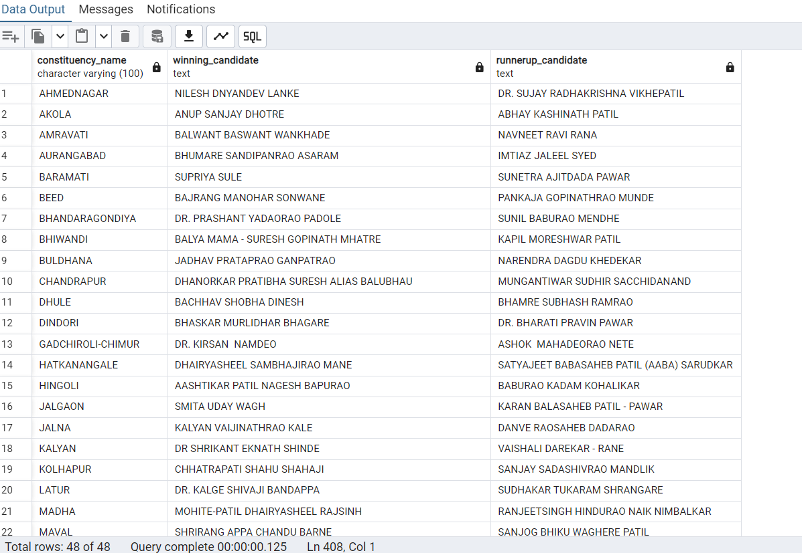

-- 15. FOR THE STATE OF MAHARASHTRA, WHAT ARE THE TOTAL NUMBER OF SEATS, TOTAL NUMBER OF CANDIDATES, TOTAL NUMBER OF PARTIES, TOTAL VOTES (INCLUDING EVM AND POSTAL), AND THE BREAKDOWN OF EVM AND POSTAL VOTES?

SELECT

COUNT(DISTINCT cr.Constituency_ID) AS Total_Seats,

COUNT(DISTINCT cd.Candidate) AS Total_Candidates,

COUNT(DISTINCT pr.Party) AS Total_Parties,

SUM(cd.EVM_Votes + cd.Postal_Votes) AS Total_Votes,

SUM(cd.EVM_Votes) AS Total_EVM_Votes,

SUM(cd.Postal_Votes) AS Total_Postal_Votes

FROM

constituencywise_results cr

JOIN

constituencywise_details cd ON cr.Constituency_ID = cd.Constituency_ID

JOIN

statewise_results sr ON cr.Parliament_Constituency = sr.Parliament_Constituency

JOIN

states s ON sr.State_ID = s.State_ID

JOIN

partywise_results pr ON cr.Party_ID = pr.Party_ID

WHERE

s.State = 'Maharashtra';

